Random Sampling Methods for Use in MProbe

Michael Capewell
August, 2002
Table of Contents

Introduction…………………………………………………………………………………………... 2
Current MProbe Method and Problem…………………………………………………………….…. 3
Qualities of an Ideal Sampling Method……………………………………………………………… 8
Methods To Be Tested…………………………………………………………………………….…. 9
Test Results…………………………………………………………………………………………... 10
Test Result Analyses ………………………………………………………………………………… 16
Comparison Chart……………………………………………………………………………………. 18
Conclusion…………………………………………………………………………………………… 19
Method Used in a Long and Thin Variable Space…………………………………………………… 20
Method Used with 3 Interior Points………………………………………………………………….. 21
In-Depth Comparison Chart………………………………………………………………………….. 22
Introduction

In MProbe, one of the main tools used to analyze constraint and objective functions is by analyzing a number of line segments distributed throughout the variable space of the mathematical program being investigated. Each line segment has two end points and a user-defined number of interior points along the line (which defaults to 3). The value of the function at the interior points is compared to those at the end points to detect if the function is linear, convex, or concave, and to what extent; and the ‘slope’ of the function can be found by comparing the values at the end points.
Current MProbe Method and Problem

Currently, MProbe generates two random end points and then places a number of interior points at equal intervals along the line segment between the two end points (by default, three interior points).

A field of random points in two dimensions would look similar to the following:

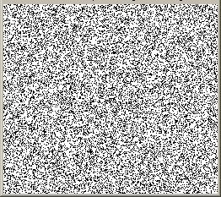

However, the method currently in use by MProbe generates points with distributions similar to the following two pictures:

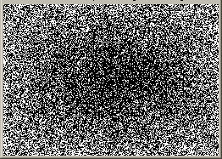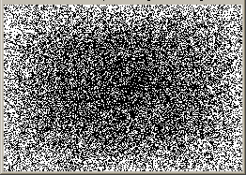
one interior point five interior points

In the following plots, the horizontal axis represents the value of a single variable (for example, x) and the vertical axis represents how many points (both end points and interior points) are recorded at that variable value. ‘Interior Pts’ is the number of interior points on a randomly generated line segment, and the Accuracy is how many recorded points each pixel represents. Higher Accuracy means that more random lines (and hence IPs) were generated to make the graph.

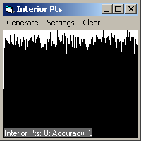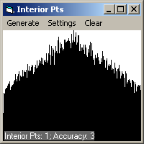

At low accuracies (low numbers of lines), one can see that the shape of the graph when there are interior points is not evenly distributed. The exact shape of the distribution, however, is not well defined and has many spikes.

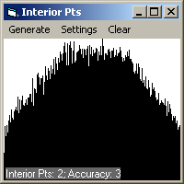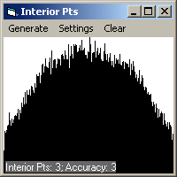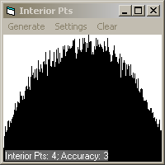

As the number of IPs increases, the shape of the graph becomes more rounded.

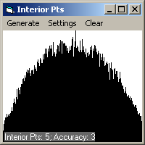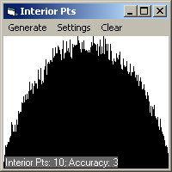

When the number of lines used increases, the actual shapes of the graphs become dramatically apparent:

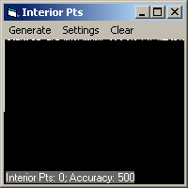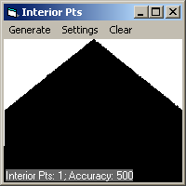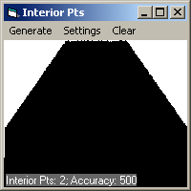

One can see that the shape of the graph is determined by the number of points per line segment. If there is one IP, the upper shape of the graph can be represented using one vertex (and two line segments), creating a triangle shape. With two IPs, the shape of the graph is made with two vertices. With n interior points, the shape is comprised of n vertices and n+1 line segments.

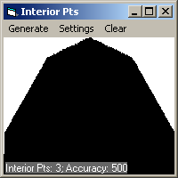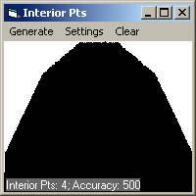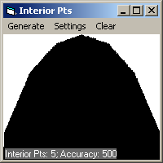

As the number of interior points increases, the graph begins to smoothen into a parabola:

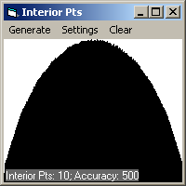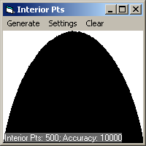

Note: Each Interior Pts graph can be divided into two parts:
- The solid rectangular area at the base is comprised of all the random end points.
- The part of the graph above the base rectangle is comprised of all the interior points.

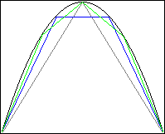
It may appear in the graphs with lower numbers of IPs that the outer ranges of the variable receives more random ‘hits,’ but, in fact, as the number of IPs increases, in these graphs, due to how they are generated, the number of lines decreases. For equal numbers of lines, the base of every graph would have approximately the same area. Consequently, the slopes of the line segments on different graphs are not related. The inset picture on the right shows the actual relations: The black line is a parabola; the grey lines represent one IP; the blue lines, two IPs; and the light-green lines, three IPs.

Next, one might wonder what the effects of interior points are with more than one variable:

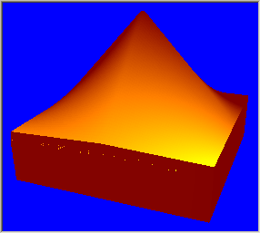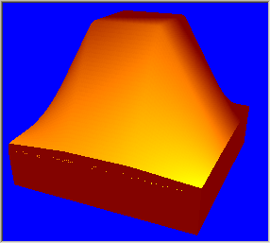
1 interior point 2 interior points
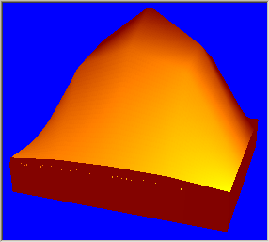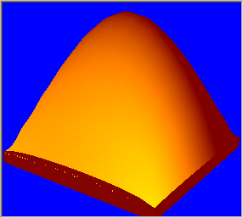
3 interior points 11 interior points

An interesting thing to note is that towards the corners, the shape does not decent in a sharp corner, but slowly spreads to the corner, making the corners extremely poorly sampled.
Qualities of an Ideal Sampling Method

From the pictures shown previously, it is obvious that the method currently in use by MProbe will give the user uneven information; the information about the interior region of the function will be greatly over-represented.
An alternative method needs to be found to replace the current method. An ideal method would have the following qualities:

Even Point Distribution: The distribution of the interior points is equal through the entire variable space, so that no area of the function is over- or under-represented. It is also desirable for the end points to be equally distributed.
Line Length Variation: The length of the lines can vary between long and short, so that features of different sizes can be detected (such as large, convex cavities and short, repeating waveforms), and the length of the lines are not dependent upon where the line is in the variable space.
Line Length Orientation: Any particular orientation of a line is equally likely at any position in the variable space, and the line’s length is not dependent upon its orientation.
Interior Point Centrality: If a line has one interior point, that interior point is equidistant from the end points. If a line has multiple interior points, the points are equally spaced out between the end points.
Execution Speed: The method can be programmed to execute at a reasonable speed.

However, no method can be perfect, as methods with advantages in one area will always have a corresponding weakness in another area. So, several alternative methods were developed. The rest of this report concerns the analyses and comparisons of these methods.
Methods to Be Tested

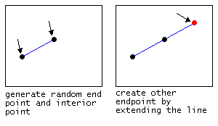
Method A:
  - Generate a random interior point and a random end point. Create the 2nd end point by mirroring the first end point across the interior point.
  - If there is a bound violation, the line segment from the interior point to the 2nd end point is shortened to a random distance from the interior point to the variable boundary. If the length of this new line segment is less than 5% of the original, the line is ignored and a new one generated.

Method B:
  - As in Method A, generate a random interior point and a random end point. Create the 2nd end point by mirroring the first end point across the interior point.
  - If there is a bound violation, the 2nd end point is placed along the variable bound, and the 1st end point is moved so that the interior point is equally spaced between the end-points.

Method C:
  - Generation of initial points: same as Method A
  - If a point violates the bounds, then bisect the line segment from that point to the interior point repeatedly until the point is in the bounds. If this line segment is less than 5% the length of the line segment between the first point and the interior point, scrap this line.

Method D:
- An interior point is randomly generated, and then a direction is randomly generated. Using a length calculated from the dimensions of the variable bounds (perhaps 1/100th of the diagonal), two end points are generated along the axis of the direction on opposite sides of the interior point.
- Ignore any lines with violations.

Method E:
  - This is the original method used by MProbe.
  - Generate two random end points, and calculate midpoints along the line.
  - There will never be bound violations.

Test Results

A Visual Basic 6.0 program was written to simulate the methods. The following pictures are of the output of the program. In the top-left corner is a density display of the interior points from inside a 200x200 unit variable space (to dimensions). The darker the colour of a pixel, the more times an interior point was recorded at that position. These pictures are of 1 million test lines.
The blue-ish regions on the right are the statistics collected from the random sample of 1 million lines. The statistics are collected for twenty 5% regions of both the X and Y variables. The percentage under the heading ‘all pts’ tells what percentage of the total number of points (both interior and end points) that fall within the corresponding 5% region. There is also a 1% region at the end (99-100%) to give an indication of what results the method gives at the extreme edges of the variable space. ‘pt1’ is the statistics for first end point generated in each line, ‘int pts,’ for the interior point on each line, and ‘pt2’ is the second end point. ‘length’ is the average length of the lines which an interior in the percent range. Below the length statistics for the percentile ranges, the average of all line lengths and the standard deviation is given.

Method A:

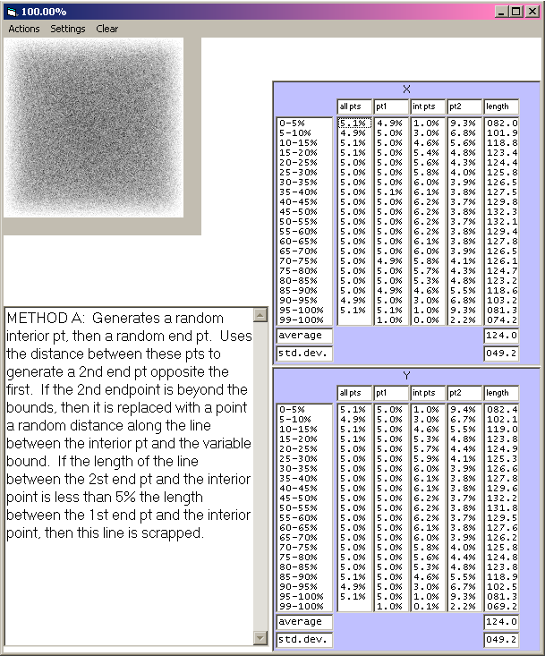
Method B:

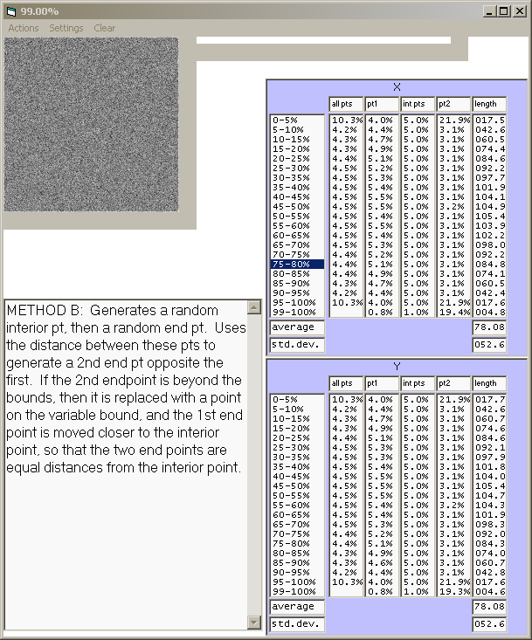
Method C:

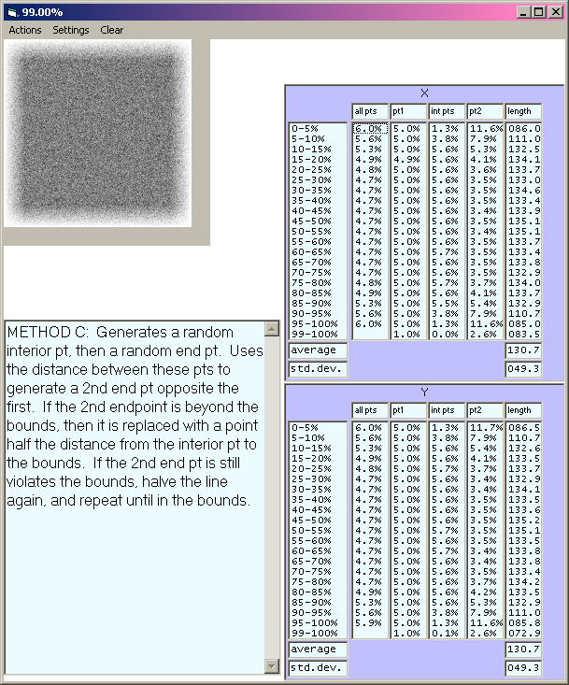
Method D:

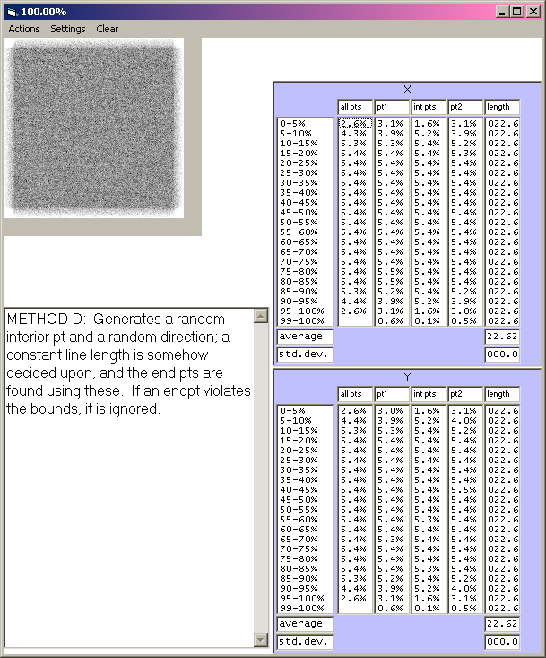
Method E:

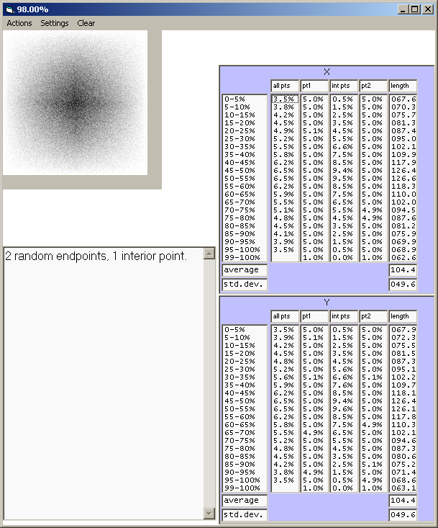
Test Results Analyses

Even Point Distribution:
Ideally, the percentage in each 5% division of the interior points (‘int pts’) column should be 5%, and in the 1% division, 1%. It is also desirable for each of the end points (‘pt1’ and ‘pt2’)
Line Length Variation:
The dimensions of the sampling region are 200 by 200 units, so lines can range from 0 to 282.8 units in length.
Line Length Orientation:
No information is given about the orientation of the lines, but long lines near the edge of the space must be orientated somewhat parallel to the bound.
Interior Point Centrality:
In these tests, the lines always have just one interior point. In methods B, D, and E, the interior point is always in the middle of the line.

Method A:

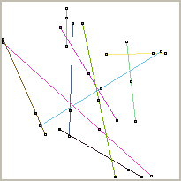
Even Point Distribution:
FAIL. The interior points are not distributed evenly. In the inner 80%, the 5% regions contain between 4.6% and 6.2% each of the interior points. However, pt1 is evenly distributed, and the combination of all the points is close to being evenly distributed (4.9% to 5.1%).
Line Length Variation:
PASS. The lengths of the lines are somewhat dependent upon the location of the line: In the centre 80%, the average line-lengths range from 118.6 to 132.3 (59.3 to 66.2% of the length of the longest dimension (200)), while the outer 1% goes down to 74.2. Compared to Method B, this is not bad. However, the reason this method can maintain fairly long lines at the edge is because the interior point is often not in the centre of line – the section of the line from the interior point to the first point retains its original length at all times.
Line Length Orientation:
PASS. Generally, the orientation of the lines will be independent of location, though towards the boundaries, lines will be slightly more likely to run parallel the bounds, due to some lines being rejected.
Interior Point Centrality:
FAIL. Since when a line violates the bounds, the line is shortened on one side of the interior point, the interior point is often not in the middle of the line, particularly toward the boundaries. This would result in inaccurate measures of degree of convexity.
Execution Speed:
PASS.
Method B:

Even Point Distribution:
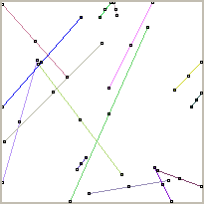
PASS. The distribution of the interior points is equal through the entire variable space, since no lines are rejected.
Line Length Variation:
FAIL. In the centre 70%, the average line lengths stay relatively similar (37.1-52.7%), which is good, but toward the edge, the line lengths drop dramatically, since lines with violations have both ends truncated equally. In the outer 5% regions, the average line length is just 8.8%, and in the outer 1% regions, 2.4%! It would be impossible to detect large-scale features at the edge (such as overall slope and deep convexities).
Line Length Orientation:
PASS. Since no line is rejected, the line orientations will not be influenced by the location of the line.
Interior Point Centrality:
PASS. The interior point is always in the centre of the line.
Execution Speed:
PASS.

Method C:
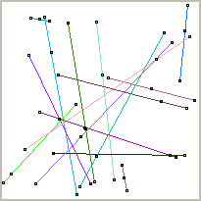
Even Point Distribution:
FAIL. In the centre 80%, the interior point is approximately constant at 5.6%, but is 1.3% and 3.8% in the outer 5 and 10% regions. Point 1 is evenly distributed, however.
Line Length Variation:
PASS. This method has the best line distribution. In the inner 80%, the average line length is fairly constant at about 66-67%
Line Length Orientation:
PASS. Method C is similar to Method A in all categories. Generally, the lines will have well-distributed orientations.
Interior Point Centrality:
FAIL. Violations are truncated on just one side of the interior point, so the interior point is not always in the centre of the line.
Execution Speed:
PASS.
Method D:

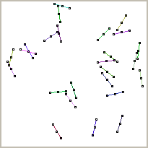
Even Point Distribution:
FAIL. In the centre region, the points are evenly distributed, but, toward the edge, violations are rejected, so the edges are under-sampled. It is impossible to sample at the corners, as well.
Line Length Variation:
PASS. The length of the lines could be controlled by the user to detect large-scale and small-scale features. This could be quite useful. However, using the other methods, the lines could be recorded and statistics generated for lines of certain lengths.
Line Length Orientation:
PASS. In the central region, the orientations are more evenly distributed than any of the other methods. However, as with all methods, towards the edge, the lines tend to be parallel the bounds.
Interior Point Centrality:
PASS. The interior point is always in the centre of the line.
Execution Speed:
PASS. In long, thin variable spaces, this method can take extremely long times. However, it should be possible to write a method that will help it correct lines that violate the bounds, so they don’t need to be rejected.

Method E:

Even Point Distribution:
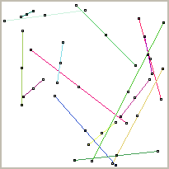
FAIL. The interior points cluster toward the centre of the variable space.
Line Length Variation:
PASS. The line lengths vary from 31.3% to 63.3% of the longest dimension.
Line Length Orientation:
PASS.
Interior Point Centrality:
PASS. All interior points are in the centre of the line.
Execution Speed:
PASS. This is the simplest and fastest method.
Comparison Chart

 | A | B | C | D | E
Even Point Distribution | FAIL | PASS | FAIL | FAIL | FAIL
Line Length Variation | PASS | FAIL | PASS | PASS | PASS
Line Length Orientation | PASS | PASS | PASS | PASS | PASS
Interior Point Centrality | FAIL | PASS | FAIL | PASS | PASS
Execution Speed | PASS | PASS | PASS | PASS | PASS
Main Advantage | Good variation in line lengths | Perfectly even interior points distribution | Slightly better than Method A for even point distribution and line length variation | Can easily inspect a function at a specific scale | Good variation in line lengths
Main Disadvantage | Interior points are not central on the line | Extremely short lines toward the edge of the variable space | Interior points are not central on the line | Can not effectively get information about the function at different scales. | Interior points are highly clustered in the centre region
Conclusions

It is really quite difficult to select a method, since none is perfect. It is easier to decide by elimination.
Method E’s sampling is too clustered in the centre of the variable space, so should be rejected.
Method D can not sample in the corners and would require more complex behaviour by the user in order to get information regarding the different scales of the function, so should be rejected.
Since C is similar to A, but slightly better in that the interior points have a more constant distribution in the centre region and the lines retain their lengths better in the outer regions, so Method A should be rejected.

This leaves methods B and C.
The main advantages of Method B are that its interior points are evenly distributed and that the line orientations are not dependent upon the position of the line; however, this comes at the price of having short lines at the variable bounds. It would be possible, though, to re-orient the lines at the bounds slightly, allowing them to be longer, and only having the effect of making the lines at the edge tend to be parallel the bounds (as in all the other methods). The effects of this would need to be investigated.
The main advantage of Method C is that the lines vary in length at all locations well. This comes at the cost of not having the interior point at the middle of the line segments. The lines at the bounds tend to be parallel to the bounds.
Neither method’s results change dramatically in long and thin variable spaces.
Since B can be modified to have better line length variation, method C really has no advantage over Method B. The final recommendation should be to use Method B with a slight modification to have long lines at the edges. The effects of this modification should be studied first, though.
Method B Used in a Long and Thin Variable Space (512x4)
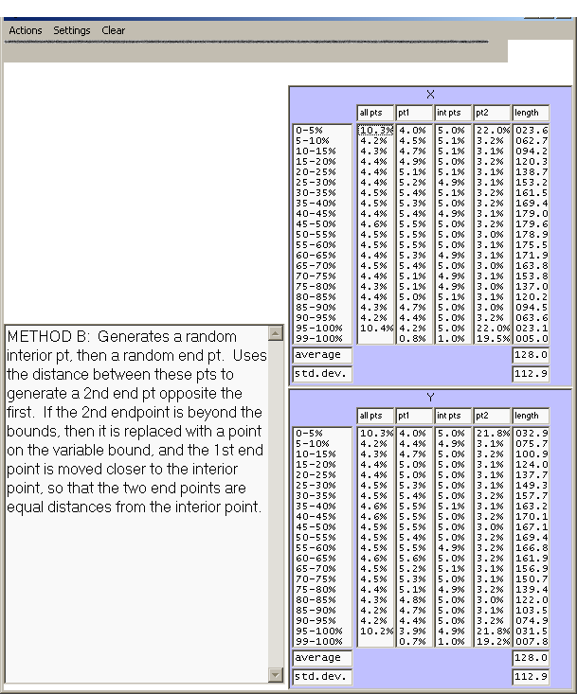
Method B Used with 3 Interior Points

The interior points cluster more toward the edges of the variable space.

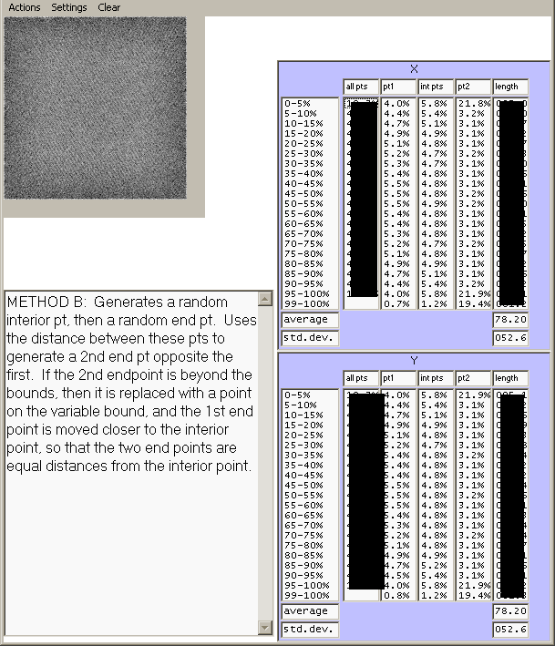

Some statistics are blacked out in this picture since they are not valid. The program was not designed with 3 interior points in mind so the line lengths statistics could not be fixed.
Corduroy effect is likely due to the Visual Basic random number generator.

 | A | B | C | D | E
Line Length Magnitude | 1D: 40%  2D: 40-62% | 1D: 63%  2D: 63-39%  dramatically shorter towards edges. | 1D: 42%  2D: 42-65% | Constant, specifiable | 1D: 33%  2D: 33-52%
Line Length Variation | 1D: 25%  2D: 25% | 1D: 56%  2D: 56-26% | 1D: 26%  2D: 26-25% | 0% | 1D: 23%  2D: 23-49%
Interior Point Distribution | 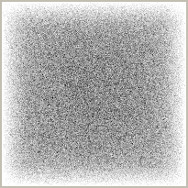  slight edge effect: outer 10% contains only 4% of int pts | 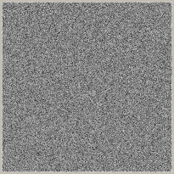  perfect | 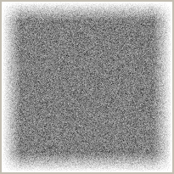  slight edge effect: similar to A, but slightly better (5.2%)  Close to constant in inner 80%. | 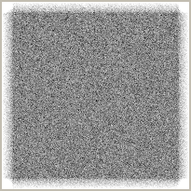  slight edge effect. Corners can not be sampled! | 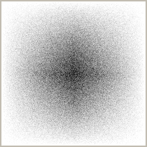  Very poor.
Even Distribution of Points | Pt1 is ± 0.1% of even | Good: Interior pt is evenly distributed.  Bad: Pt 2 is highly concentrated on the outer edge (22%) | Pt1 is closer to being evenly distributed than in A. | Corners can not be sampled! | The endpoints are evenly distributed
Interior Point in Centre of Line | no | yes | no | Yes | yes
Execution Speed |  |  |  | Unusably slow in long&thin spaces. Could possibly be adjusted to be faster, however | Fastest

======================================================================
this part was not part of the original report. I thought of it a few weeks after submitting the report.
======================================================================

All the sampling methods discussed before had one thing in common: they used two endpoints as reference points, then used a centre point to get information about concavity. This caused the problems detailed above (mainly, problems with the fact that taking information from the middle point over-sampled the central area of the variable-space, and left the edges relatively unsampled).
I think it could be possible to generate two random endpoints, then find the centre of that line, but, instead of using the centre point to get information, use one of the end points. This method isn’t as intuitive, but maybe could work. This idea should be analyzed, and experiments should be done comparing data generated using this method and data generated using method B, with the true values that should be obtained from several varied, well-understood models.

On the left, the centre-point-based method. On the right, my idea….
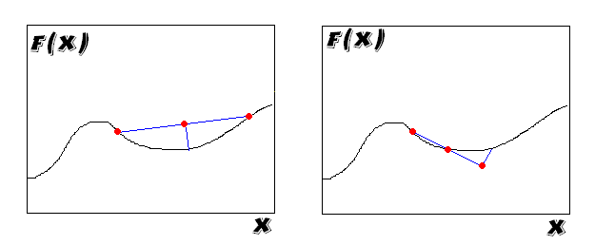

One problem that is a bit obvious in this diagram, is that the line could extend beyond the allowed variable value (imagine if the right X bound were right on the right-most point)

